How to open aem project

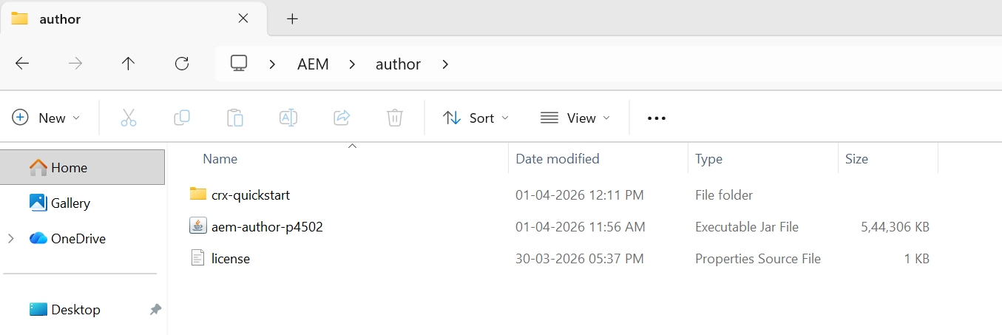

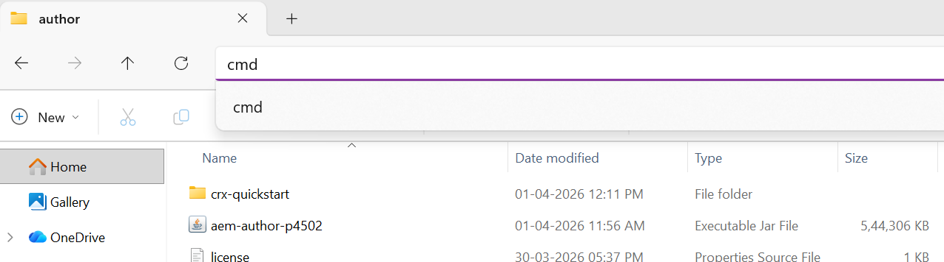

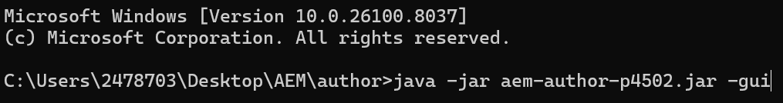

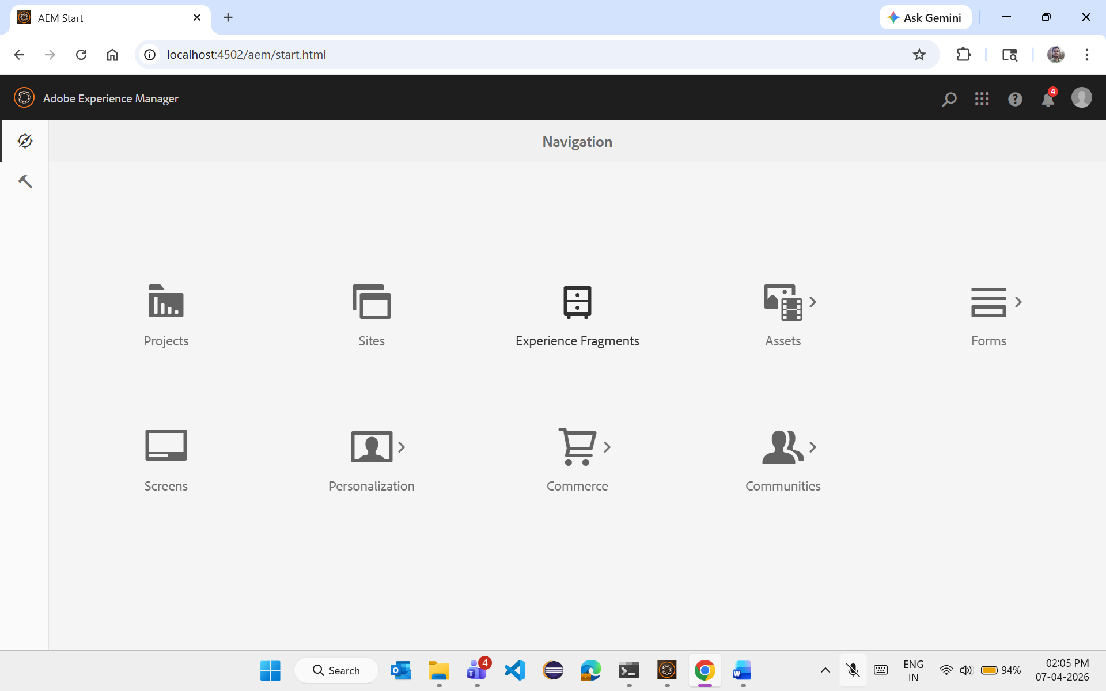

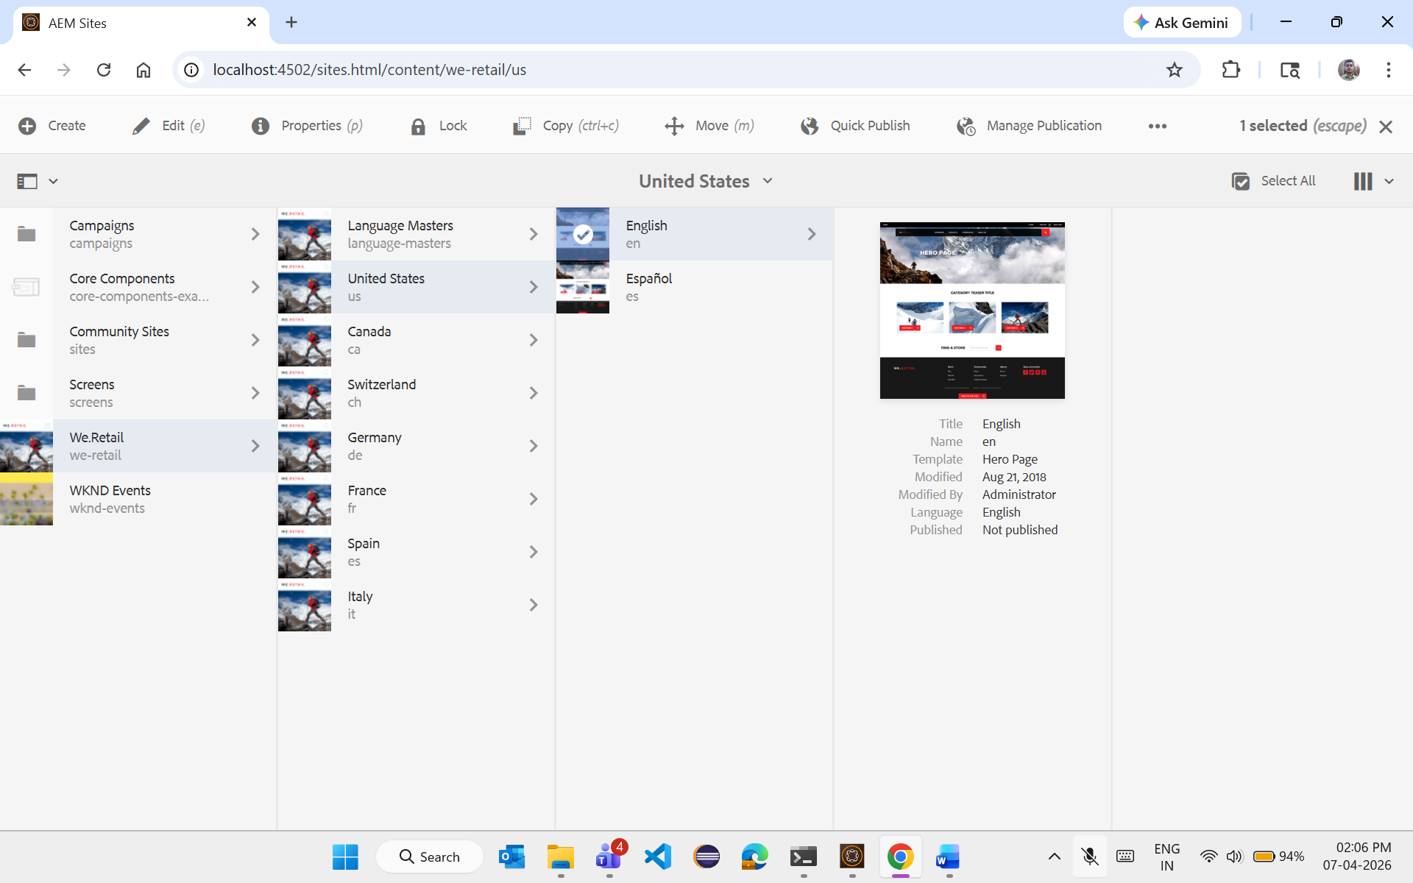

How to create aem project??



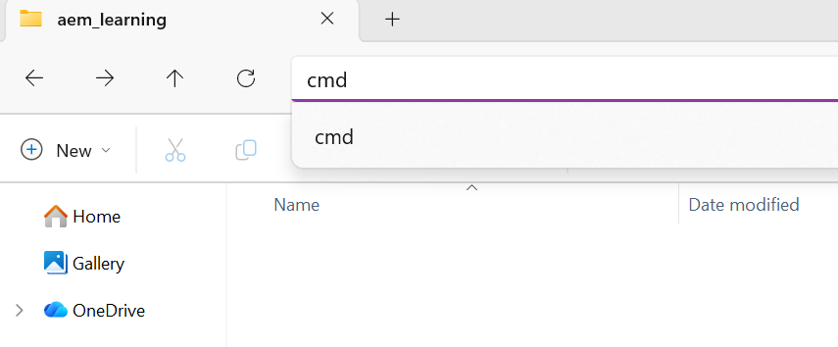
mvn -B archetype:generate -DarchetypeGroupId=com.adobe.aem -DarchetypeArtifactId=aem-project-archetype -DarchetypeVersion=56 -DaemVersion=6.5.22 -DartifactId=genc-aem-training -DappTitle="GenC AEM Training" -DappId="genc-aem-training" -DgroupId="com.genc.core" -DincludeDispatcherConfig=n -DfrontendModule=none

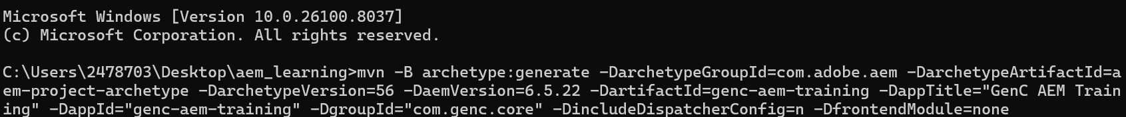

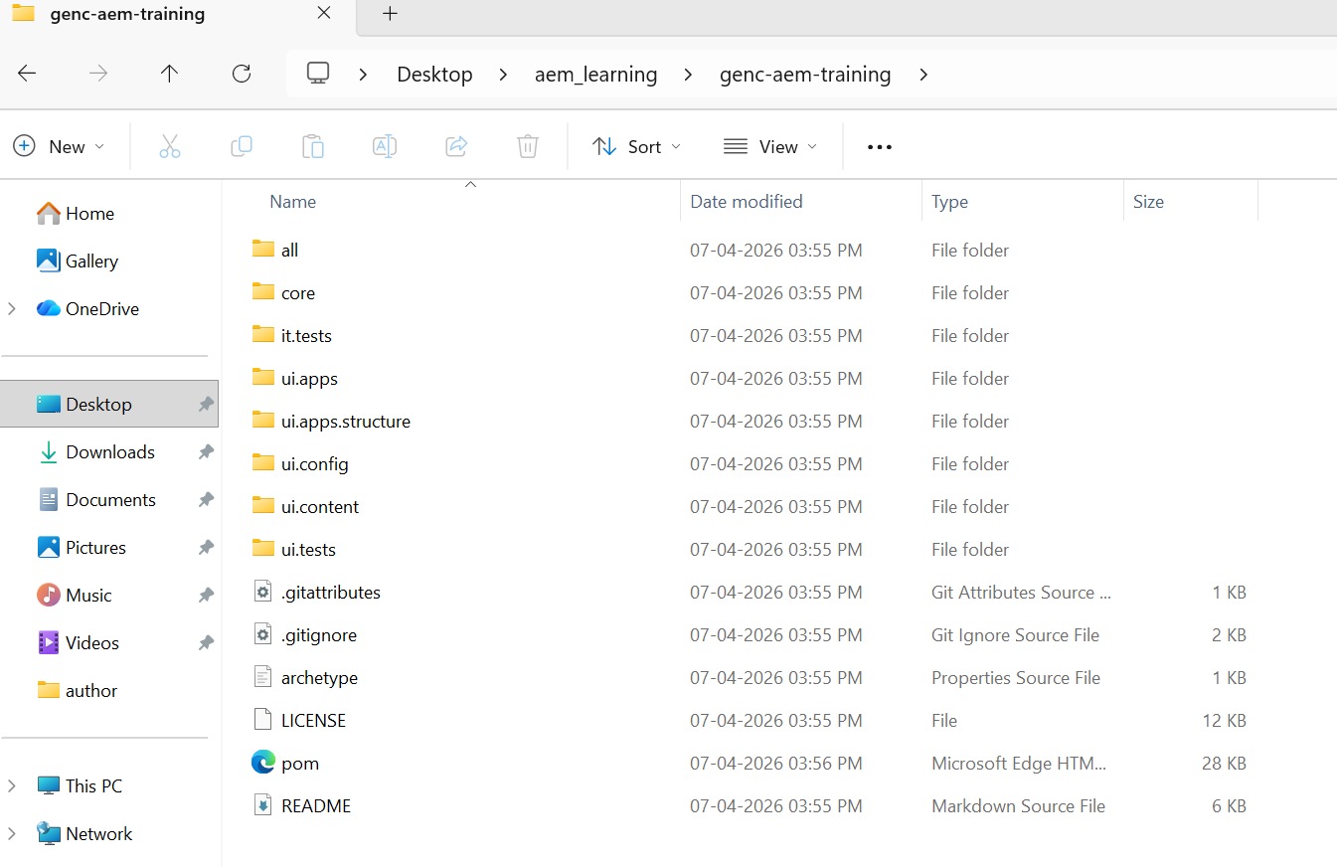

<?xml version="1.0" encoding="UTF-8"?><!--
| Copyright 2015 Adobe Systems Incorporated
|
| Licensed under the Apache License, Version 2.0 (the "License");
| you may not use this file except in compliance with the License.
| You may obtain a copy of the License at
|
| http://www.apache.org/licenses/LICENSE-2.0
|
| Unless required by applicable law or agreed to in writing, software
| distributed under the License is distributed on an "AS IS" BASIS,
| WITHOUT WARRANTIES OR CONDITIONS OF ANY KIND, either express or implied.
| See the License for the specific language governing permissions and
| limitations under the License.
--><project xmlns="http://maven.apache.org/POM/4.0.0" xmlns:xsi="http://www.w3.org/2001/XMLSchema-instance" xsi:schemaLocation="http://maven.apache.org/POM/4.0.0 http://maven.apache.org/maven-v4_0_0.xsd">
<modelVersion>4.0.0</modelVersion>
<groupId>com.genc.core</groupId>
<artifactId>genc-aem-training</artifactId>
<packaging>pom</packaging>
<version>1.0.0-SNAPSHOT</version>
<name>GenC AEM Training</name>
<description>GenC AEM Training</description>
<modules>
<module>all</module>
<module>core</module>
<module>ui.apps</module>
<module>ui.apps.structure</module>
<module>ui.config</module>
<module>ui.content</module>
<module>it.tests</module>
<!-- ui.tests removed: Cypress requires Node.js download from internet which is blocked by corporate SSL (Zscaler) -->
</modules>
<properties>
<aem.host>localhost</aem.host>
<aem.port>4502</aem.port>
<aem.publish.host>localhost</aem.publish.host>
<aem.publish.port>4503</aem.publish.port>
<sling.user>admin</sling.user>
<sling.password>admin</sling.password>
<vault.user>admin</vault.user>
<vault.password>admin</vault.password>
<frontend-maven-plugin.version>1.12.0</frontend-maven-plugin.version>
<core.wcm.components.version>2.28.0</core.wcm.components.version>
<bnd.version>6.4.0</bnd.version>
<project.build.sourceEncoding>UTF-8</project.build.sourceEncoding>
<project.reporting.outputEncoding>UTF-8</project.reporting.outputEncoding>
<componentGroupName>GenC AEM Training</componentGroupName>
</properties>
<build>
<plugins>
<!-- Maven Release Plugin -->
<plugin>
<groupId>org.apache.maven.plugins</groupId>
<artifactId>maven-release-plugin</artifactId>
<version>2.5.3</version>
<configuration>
<scmCommentPrefix>[maven-scm] :</scmCommentPrefix>
<preparationGoals>clean install</preparationGoals>
<goals>install</goals>
<releaseProfiles>release</releaseProfiles>
</configuration>
</plugin>
<!-- Maven Source Plugin -->
<plugin>
<groupId>org.apache.maven.plugins</groupId>
<artifactId>maven-source-plugin</artifactId>
<version>3.0.1</version>
<inherited>true</inherited>
</plugin>
<!-- Maven Enforcer Plugin -->
<plugin>
<groupId>org.apache.maven.plugins</groupId>
<artifactId>maven-enforcer-plugin</artifactId>
<executions>
<execution>
<id>enforce-maven</id>
<goals>
<goal>enforce</goal>
</goals>
<configuration>
<rules>
<requireMavenVersion>
<version>[3.3.9,)</version>
</requireMavenVersion>
<requireJavaVersion>
<message>Maven must be executed with a Java 11 JRE or higher.</message>
<version>11</version>
</requireJavaVersion>
</rules>
</configuration>
</execution>
</executions>
</plugin>
<!-- Maven Compiler Plugin -->
<plugin>
<groupId>org.apache.maven.plugins</groupId>
<artifactId>maven-compiler-plugin</artifactId>
<configuration>
<release>11</release>
</configuration>
</plugin>
</plugins>
<pluginManagement>
<plugins>
<plugin>
<groupId>org.apache.maven.plugins</groupId>
<artifactId>maven-assembly-plugin</artifactId>
<version>3.3.0</version>
<configuration>
<tarLongFileMode>posix</tarLongFileMode>
</configuration>
</plugin>
<plugin>
<groupId>com.github.eirslett</groupId>
<artifactId>frontend-maven-plugin</artifactId>
<version>${frontend-maven-plugin.version}</version>
<configuration>
<nodeVersion>v16.17.0</nodeVersion>
<npmVersion>8.15.0</npmVersion>
</configuration>
<executions>
<execution>
<id>install node and npm</id>
<goals>
<goal>install-node-and-npm</goal>
</goals>
</execution>
<execution>
<id>npm ci</id>
<goals>
<goal>npm</goal>
</goals>
<configuration>
<arguments>ci</arguments>
</configuration>
</execution>
</executions>
</plugin>
<!-- Maven Jar Plugin -->
<plugin>
<groupId>org.apache.maven.plugins</groupId>
<artifactId>maven-jar-plugin</artifactId>
<version>3.1.2</version>
</plugin>
<!-- Maven Clean Plugin -->
<plugin>
<groupId>org.apache.maven.plugins</groupId>
<artifactId>maven-clean-plugin</artifactId>
<version>3.0.0</version>
</plugin>
<!-- BND Maven Plugin -->
<plugin>
<groupId>biz.aQute.bnd</groupId>
<artifactId>bnd-maven-plugin</artifactId>
<version>${bnd.version}</version>
<executions>
<execution>
<id>bnd-process</id>
<goals>
<goal>bnd-process</goal>
</goals>
<configuration>
<bnd>
Bundle-Category: ${componentGroupName}

# export all versioned packages except for conditional ones (https://github.com/bndtools/bnd/issues/3721#issuecomment-579026778)
-exportcontents: ${removeall;${packages;VERSIONED};${packages;CONDITIONAL}}

# reproducible builds (https://github.com/bndtools/bnd/issues/3521)
-noextraheaders: true
-snapshot: SNAPSHOT

Bundle-DocURL:
-plugin org.apache.sling.caconfig.bndplugin.ConfigurationClassScannerPlugin
-plugin org.apache.sling.bnd.models.ModelsScannerPlugin
</bnd>
</configuration>
</execution>
</executions>
<dependencies>
<dependency>
<groupId>org.apache.sling</groupId>
<artifactId>org.apache.sling.caconfig.bnd-plugin</artifactId>
<version>1.0.2</version>
</dependency>
<dependency>
<groupId>org.apache.sling</groupId>
<artifactId>org.apache.sling.bnd.models</artifactId>
<version>1.0.0</version>
</dependency>
<dependency>
<groupId>org.apache.sling</groupId>
<artifactId>scriptingbundle-maven-plugin</artifactId>
<version>0.5.0</version>
</dependency>
</dependencies>
</plugin>
<plugin>
<groupId>biz.aQute.bnd</groupId>
<artifactId>bnd-baseline-maven-plugin</artifactId>
<version>${bnd.version}</version>
</plugin>
<!-- Maven Resources Plugin -->
<plugin>
<groupId>org.apache.maven.plugins</groupId>
<artifactId>maven-resources-plugin</artifactId>
<version>3.0.2</version>
</plugin>
<!-- Maven Compiler Plugin -->
<plugin>
<groupId>org.apache.maven.plugins</groupId>
<artifactId>maven-compiler-plugin</artifactId>
<version>3.8.1</version>
</plugin>
<!-- Maven Installer Plugin -->
<plugin>
<groupId>org.apache.maven.plugins</groupId>
<artifactId>maven-install-plugin</artifactId>
<version>2.5.2</version>
</plugin>
<!-- Maven Surefire Plugin -->
<plugin>
<groupId>org.apache.maven.plugins</groupId>
<artifactId>maven-surefire-plugin</artifactId>
<version>2.22.1</version>
<configuration>
<useSystemClassLoader>false</useSystemClassLoader>
</configuration>
</plugin>
<!-- Maven Failsafe Plugin -->
<plugin>
<groupId>org.apache.maven.plugins</groupId>
<artifactId>maven-failsafe-plugin</artifactId>
<version>2.22.1</version>
</plugin>
<!-- Maven Deploy Plugin -->
<plugin>
<groupId>org.apache.maven.plugins</groupId>
<artifactId>maven-deploy-plugin</artifactId>
<version>2.8.2</version>
</plugin>
<!-- Apache Sling Plugin -->
<plugin>
<groupId>org.apache.sling</groupId>
<artifactId>sling-maven-plugin</artifactId>
<version>2.4.0</version>
<configuration>
<slingUrl>http://${aem.host}:${aem.port}/system/console</slingUrl>
<deploymentMethod>WebConsole</deploymentMethod>
</configuration>
</plugin>
<!-- HTL Maven Plugin -->
<plugin>
<groupId>org.apache.sling</groupId>
<artifactId>htl-maven-plugin</artifactId>
<version>2.0.2-1.4.0</version>
<configuration>
<failOnWarnings>true</failOnWarnings>
</configuration>
</plugin>
<!-- Jackrabbit FileVault Package Plugin -->
<plugin>
<groupId>org.apache.jackrabbit</groupId>
<artifactId>filevault-package-maven-plugin</artifactId>
<extensions>true</extensions>
<version>1.3.6</version>
<configuration>
<filterSource>src/main/content/META-INF/vault/filter.xml</filterSource>
<validatorsSettings>
<jackrabbit-nodetypes>
<options>
<!-- use the nodetypes and namespaces from the aem-nodetypes.jar provided in the plugin dependencies -->
<cnds>tccl:aem.cnd</cnds>
</options>
</jackrabbit-nodetypes>
</validatorsSettings>
</configuration>
<dependencies>
<dependency>
<groupId>biz.netcentric.aem</groupId>
<artifactId>aem-nodetypes</artifactId>
<version>6.5.7.0</version>
</dependency>
</dependencies>
</plugin>
<!-- AEM Analyser Plugin -->
<plugin>
<groupId>com.adobe.aem</groupId>
<artifactId>aemanalyser-maven-plugin</artifactId>
<version>${aemanalyser.version}</version>
<extensions>true</extensions>
</plugin>
<!-- Content Package Plugin -->
<plugin>
<groupId>com.day.jcr.vault</groupId>
<artifactId>content-package-maven-plugin</artifactId>
<version>1.0.6</version>
<configuration>
<targetURL>http://${aem.host}:${aem.port}/crx/packmgr/service.jsp</targetURL>
<failOnError>true</failOnError>
<userId>${vault.user}</userId>
<password>${vault.password}</password>
</configuration>
</plugin>
<!-- Maven Enforcer Plugin -->
<plugin>
<groupId>org.apache.maven.plugins</groupId>
<artifactId>maven-enforcer-plugin</artifactId>
<version>3.0.0</version>
</plugin>
<!-- Maven Dependency Plugin -->
<plugin>
<groupId>org.apache.maven.plugins</groupId>
<artifactId>maven-dependency-plugin</artifactId>
<version>3.0.0</version>
</plugin>
<!-- Build Helper Maven Plugin -->
<plugin>
<groupId>org.codehaus.mojo</groupId>
<artifactId>build-helper-maven-plugin</artifactId>
<version>3.0.0</version>
</plugin>
<!--This plugin's configuration is used to store Eclipse
m2e settings only. It has no influence on the Maven build itself. -->
<plugin>
<groupId>org.eclipse.m2e</groupId>
<artifactId>lifecycle-mapping</artifactId>
<version>1.0.0</version>
<configuration>
<lifecycleMappingMetadata>
<pluginExecutions>
<pluginExecution>
<pluginExecutionFilter>
<groupId>org.apache.maven.plugins</groupId>
<artifactId>maven-enforcer-plugin</artifactId>
<versionRange>[1.0.0,)</versionRange>
<goals>
<goal>enforce</goal>
</goals>
</pluginExecutionFilter>
<action>
<ignore/>
</action>
</pluginExecution>
<pluginExecution>
<pluginExecutionFilter>
<groupId>
org.apache.maven.plugins
</groupId>
<artifactId>
maven-dependency-plugin
</artifactId>
<versionRange>
[2.2,)
</versionRange>
<goals>
<goal>copy-dependencies</goal>
<goal>unpack</goal>
</goals>
</pluginExecutionFilter>
<action>
<ignore/>
</action>
</pluginExecution>
<pluginExecution>
<pluginExecutionFilter>
<groupId>
org.codehaus.mojo
</groupId>
<artifactId>
build-helper-maven-plugin
</artifactId>
<versionRange>
[1.5,)
</versionRange>
<goals>
<goal>
reserve-network-port
</goal>
</goals>
</pluginExecutionFilter>
<action>
<ignore/>
</action>
</pluginExecution>
</pluginExecutions>
</lifecycleMappingMetadata>
</configuration>
</plugin>
</plugins>
</pluginManagement>
</build>
<profiles>
<!-- ====================================================== -->
<!-- A D O B E P U B L I C P R O F I L E -->
<!-- ====================================================== -->
<profile>
<id>adobe-public</id>
<activation>
<activeByDefault>true</activeByDefault>
</activation>
<properties>
<releaseRepository-Id>adobe-public-releases</releaseRepository-Id>
<releaseRepository-Name>Adobe Public Releases</releaseRepository-Name>
<releaseRepository-URL>https://repo.adobe.com/nexus/content/groups/public</releaseRepository-URL>
</properties>
<repositories>
<repository>
<id>adobe-public-releases</id>
<name>Adobe Public Repository</name>
<url>https://repo.adobe.com/nexus/content/groups/public</url>
<releases>
<enabled>true</enabled>
<updatePolicy>never</updatePolicy>
</releases>
<snapshots>
<enabled>false</enabled>
</snapshots>
</repository>
</repositories>
<pluginRepositories>
<pluginRepository>
<id>adobe-public-releases</id>
<name>Adobe Public Repository</name>
<url>https://repo.adobe.com/nexus/content/groups/public</url>
<releases>
<enabled>true</enabled>
<updatePolicy>never</updatePolicy>
</releases>
<snapshots>
<enabled>false</enabled>
</snapshots>
</pluginRepository>
</pluginRepositories>
</profile>
<!-- Development profile: install only the bundle -->
<profile>
<id>autoInstallBundle</id>
<!--
To enable this feature for a bundle, the sling-maven-plugin
(without configuration) needs to be included:

<plugin>
<groupId>org.apache.sling</groupId>
<artifactId>sling-maven-plugin</artifactId>
</plugin>
-->
<activation>
<activeByDefault>false</activeByDefault>
</activation>
<build>
<pluginManagement>
<plugins>
<plugin>
<groupId>org.apache.sling</groupId>
<artifactId>sling-maven-plugin</artifactId>
<executions>
<execution>
<id>install-bundle</id>
<goals>
<goal>install</goal>
</goals>
</execution>
</executions>
</plugin>
</plugins>
</pluginManagement>
</build>
</profile>
<profile>
<id>autoInstallPackage</id>
<activation>
<activeByDefault>false</activeByDefault>
</activation>
<build>
<pluginManagement>
<plugins>
<plugin>
<groupId>org.apache.jackrabbit</groupId>
<artifactId>filevault-package-maven-plugin</artifactId>
<executions>
<execution>
<id>create-package</id>
<goals>
<goal>package</goal>
</goals>
</execution>
</executions>
</plugin>
<plugin>
<groupId>com.day.jcr.vault</groupId>
<artifactId>content-package-maven-plugin</artifactId>
<executions>
<execution>
<id>install-package</id>
<goals>
<goal>install</goal>
</goals>
<configuration>
<targetURL>http://${aem.host}:${aem.port}/crx/packmgr/service.jsp</targetURL>
</configuration>
</execution>
</executions>
</plugin>
</plugins>
</pluginManagement>
</build>
</profile>
<profile>
<id>autoInstallPackagePublish</id>
<activation>
<activeByDefault>false</activeByDefault>
</activation>
<build>
<pluginManagement>
<plugins>
<plugin>
<groupId>org.apache.jackrabbit</groupId>
<artifactId>filevault-package-maven-plugin</artifactId>
<executions>
<execution>
<id>create-package</id>
<goals>
<goal>package</goal>
</goals>
</execution>
</executions>
</plugin>
<plugin>
<groupId>com.day.jcr.vault</groupId>
<artifactId>content-package-maven-plugin</artifactId>
<executions>
<execution>
<id>install-package-publish</id>
<goals>
<goal>install</goal>
</goals>
<configuration>
<targetURL>http://${aem.publish.host}:${aem.publish.port}/crx/packmgr/service.jsp</targetURL>
</configuration>
</execution>
</executions>
</plugin>
</plugins>
</pluginManagement>
</build>
</profile>
<profile>
<id>autoInstallSinglePackage</id>
<activation>
<activeByDefault>false</activeByDefault>
</activation>
<build>
<pluginManagement>
<plugins>
<plugin>
<groupId>org.apache.jackrabbit</groupId>
<artifactId>filevault-package-maven-plugin</artifactId>
<executions>
<execution>
<id>create-package</id>
<goals>
<goal>package</goal>
</goals>
</execution>
</executions>
</plugin>
<plugin>
<groupId>com.day.jcr.vault</groupId>
<artifactId>content-package-maven-plugin</artifactId>
<executions>
<execution>
<id>install-package</id>
<goals>
<goal>install</goal>
</goals>
<configuration>
<targetURL>http://${aem.host}:${aem.port}/crx/packmgr/service.jsp</targetURL>
<packageFile>${project.build.directory}/${project.build.finalName}.zip</packageFile>
</configuration>
</execution>
</executions>
</plugin>
</plugins>
</pluginManagement>
</build>
</profile>
</profiles>
<!-- ====================================================================== -->
<!-- D E P E N D E N C I E S -->
<!-- ====================================================================== -->
<dependencyManagement>
<dependencies>
<!-- OSGi Dependencies -->
<dependency>
<groupId>org.osgi</groupId>
<artifactId>org.osgi.annotation.versioning</artifactId>
<version>1.1.0</version>
<scope>provided</scope>
</dependency>
<dependency>
<groupId>org.osgi</groupId>
<artifactId>org.osgi.annotation.bundle</artifactId>
<version>1.0.0</version>
<scope>provided</scope>
</dependency>
<dependency>
<groupId>org.osgi</groupId>
<artifactId>org.osgi.service.metatype.annotations</artifactId>
<version>1.4.0</version>
<scope>provided</scope>
</dependency>
<dependency>
<groupId>org.osgi</groupId>
<artifactId>org.osgi.service.component.annotations</artifactId>
<version>1.4.0</version>
<scope>provided</scope>
</dependency>
<dependency>
<groupId>org.osgi</groupId>
<artifactId>org.osgi.service.component</artifactId>
<version>1.4.0</version>
<scope>provided</scope>
</dependency>
<dependency>
<groupId>org.osgi</groupId>
<artifactId>org.osgi.service.cm</artifactId>
<version>1.6.0</version>
<scope>provided</scope>
</dependency>
<dependency>
<groupId>org.osgi</groupId>
<artifactId>org.osgi.service.event</artifactId>
<version>1.3.1</version>
<scope>provided</scope>
</dependency>
<dependency>
<groupId>org.osgi</groupId>
<artifactId>org.osgi.service.log</artifactId>
<version>1.4.0</version>
<scope>provided</scope>
</dependency>
<dependency>
<groupId>org.osgi</groupId>
<artifactId>org.osgi.resource</artifactId>
<version>1.0.0</version>
<scope>provided</scope>
</dependency>
<dependency>
<groupId>org.osgi</groupId>
<artifactId>org.osgi.framework</artifactId>
<version>1.9.0</version>
<scope>provided</scope>
</dependency>
<dependency>
<groupId>org.osgi</groupId>
<artifactId>org.osgi.util.tracker</artifactId>
<version>1.5.1</version>
<scope>provided</scope>
</dependency>
<dependency>
<groupId>org.apache.sling</groupId>
<artifactId>org.apache.sling.servlets.annotations</artifactId>
<version>1.2.4</version>
<scope>provided</scope>
</dependency>
<!-- Logging Dependencies -->
<dependency>
<groupId>org.slf4j</groupId>
<artifactId>slf4j-api</artifactId>
<version>1.7.21</version>
<scope>provided</scope>
</dependency>
<dependency>
<groupId>org.slf4j</groupId>
<artifactId>slf4j-simple</artifactId>
<version>1.7.25</version>
<scope>test</scope>
</dependency>
<!-- Adobe AEM Dependencies -->
<dependency>
<groupId>com.adobe.aem</groupId>
<artifactId>uber-jar</artifactId>
<version>6.5.22</version>
<scope>provided</scope>
</dependency>
<!-- Apache Sling Dependencies -->
<dependency>
<groupId>org.apache.sling</groupId>
<artifactId>org.apache.sling.models.api</artifactId>
<version>1.3.6</version>
<scope>provided</scope>
</dependency>
<!-- Servlet API -->
<dependency>
<groupId>javax.servlet</groupId>
<artifactId>javax.servlet-api</artifactId>
<version>3.1.0</version>
<scope>provided</scope>
</dependency>
<dependency>
<groupId>javax.servlet.jsp</groupId>
<artifactId>jsp-api</artifactId>
<version>2.1</version>
<scope>provided</scope>
</dependency>
<dependency>
<groupId>javax.annotation</groupId>
<artifactId>javax.annotation-api</artifactId>
<version>1.3.2</version>
<scope>provided</scope>
</dependency>
<!-- JCR -->
<dependency>
<groupId>javax.jcr</groupId>
<artifactId>jcr</artifactId>
<version>2.0</version>
<scope>provided</scope>
</dependency>
<dependency>
<groupId>com.adobe.cq</groupId>
<artifactId>core.wcm.components.core</artifactId>
<version>${core.wcm.components.version}</version>
</dependency>
<dependency>
<groupId>com.adobe.cq</groupId>
<artifactId>core.wcm.components.content</artifactId>
<type>zip</type>
<version>${core.wcm.components.version}</version>
</dependency>
<dependency>
<groupId>com.adobe.cq</groupId>
<artifactId>core.wcm.components.config</artifactId>
<type>zip</type>
<version>${core.wcm.components.version}</version>
</dependency>
<!-- Testing -->
<dependency>
<groupId>org.junit</groupId>
<artifactId>junit-bom</artifactId>
<version>5.8.2</version>
<type>pom</type>
<scope>import</scope>
</dependency>
<dependency>
<groupId>org.mockito</groupId>
<artifactId>mockito-core</artifactId>
<version>4.1.0</version>
<scope>test</scope>
</dependency>
<dependency>
<groupId>org.mockito</groupId>
<artifactId>mockito-junit-jupiter</artifactId>
<version>4.1.0</version>
<scope>test</scope>
</dependency>
<dependency>
<groupId>junit-addons</groupId>
<artifactId>junit-addons</artifactId>
<version>1.4</version>
<scope>test</scope>
</dependency>
<dependency>
<groupId>io.wcm</groupId>
<artifactId>io.wcm.testing.aem-mock.junit5</artifactId>
<version>5.5.4</version>
<scope>test</scope>
<exclusions>
<exclusion>
<groupId>org.apache.sling</groupId>
<artifactId>org.apache.sling.scripting.api</artifactId>
</exclusion>
</exclusions>
</dependency>
<dependency>
<groupId>org.apache.sling</groupId>
<artifactId>org.apache.sling.testing.caconfig-mock-plugin</artifactId>
<version>1.4.0</version>
<exclusions>
<exclusion>
<groupId>commons-collections</groupId>
<artifactId>commons-collections</artifactId>
</exclusion>
</exclusions>
</dependency>
<dependency>
<groupId>commons-collections</groupId>
<artifactId>commons-collections</artifactId>
<version>3.2.2</version>
<scope>provided</scope>
</dependency>
<dependency>
<groupId>com.adobe.cq</groupId>
<artifactId>core.wcm.components.testing.aem-mock-plugin</artifactId>
<version>${core.wcm.components.version}</version>
<scope>test</scope>
<exclusions>
<exclusion>
<groupId>org.apache.sling</groupId>
<artifactId>org.apache.sling.scripting.api</artifactId>
</exclusion>
</exclusions>
</dependency>
<dependency>
<groupId>uk.org.lidalia</groupId>
<artifactId>slf4j-test</artifactId>
<version>1.0.1</version>
<scope>test</scope>
</dependency>
</dependencies>
</dependencyManagement>
</project>
